B22DCDT059 – Trần Anh Dũng
Ques1
a.
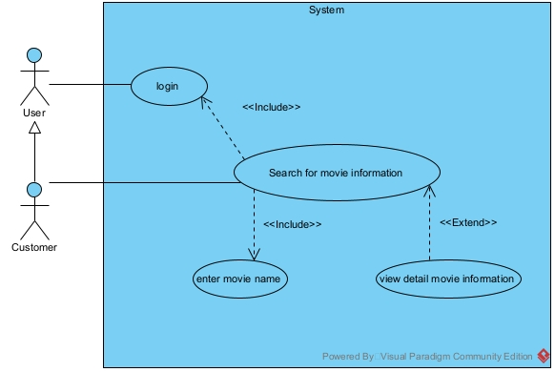
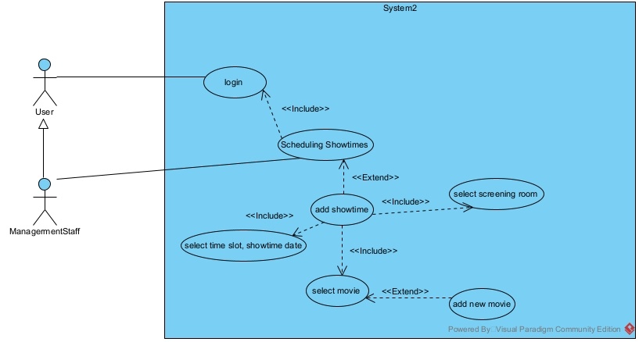
b.
Ques2
a. Entity Extract
- User: username, password, role, fullName
- Saler
- ManagementStaff
- Customer: age, phone, point, address
- Movie: name, length, ageRating, genre
- ShowtiemSlot: date, type
- Room: name, capacity
- Seat: name, type
- Ticket: price
- TimeSlot: time
- Invoice: date, totalPrice
b.
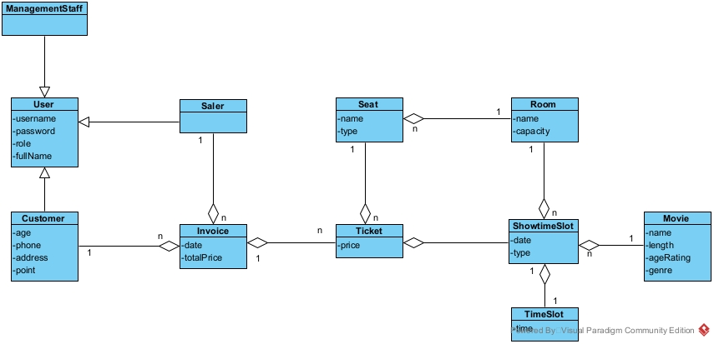
Ques3
a.
b.
Ques4
a.
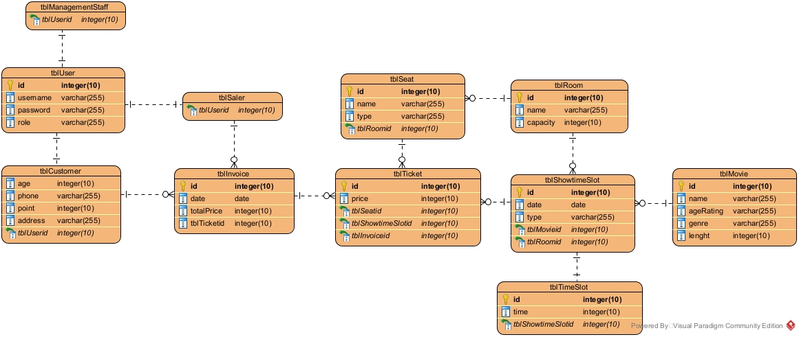
b.

